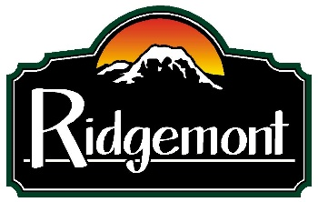

Dear Ridgemont HOA resident:

We are pleased to provide you with this quick review of your 2021 HOA dues dollars at work and provide you with some important information.

Here is what your board members do for you:
- Maintain all legal and financial documentation
- Ensure that all legal state and federal requirements are met
- Process architectural improvements.
- Maintain all bank accounts
- Assess and initiate regular maintenance issues, and
- Work to ensure that all dues are current

Monthly Costs:
- Electricity for the streetlights.
- Water for the sprinkler systems in the entrance and at the park.
- Bank Fees
- Landscaping maintenance
- Mailbox
- HOA Insurance

Bi-Annual Costs:
- Storm pond cleaning – 2 times annually per Pierce County
- Street cleaning – 2 times annually

Annual Costs:
- Taxes on property owned by the HOA
- As needed:
  - Emergency repairs
  - Repair of any community items such as fencing, playground equipment or signs.

General for 2021:
- The front and park sprinkler systems were replaced a while back, but the job was subpar, and we are in the process of obtaining bids to have them repaired.
- Priority was given to get in-house financials resolved.
- Achieved receipt of 98% of HOA due payments with only one being currently delinquent.
- A new financial plan was created to address our low Reserve Study.
- New initiative to go 90% paperless to save on increasing mailing & storage costs.
- New initiative in process of being created to obtain correct information from all residents in order to provide notices and other items in a timely manner.
- The required Pierce County Public Works Annual inspection was completed.
- All Catch Basins passed the annual Pierce County inspection.
- Establishment of an official RHOA Complaint & ACC form.
- A new official website was launched: www.ridgemonthoa.com.
- Provided several HOA request for real estate demands

As note:

As one can imagine, that the older a development becomes, the more things will be need of improvement and prices go up. Many of these items are required by State and Federal entities and the HOA has no choice but to comply with these requirements.

As such, Ridgemont HOA find themselves in the unfortunate position of having to raise prices to cover those improvements. The annual dues are being increased by 5% to a total of $336.00.

And here is the reason:

The Ridgemont HOA, while improving, is still reeling from a very mis-managed HOA in years past where dues were not collected properly, bills were not paid as needed and things were not maintained. When the new board was installed, they found that we had a lot of “catching-up” to do, and no money to do it with.

Currently your dues pay for just the basic items listed on the previous page. The HOA currently does not have the reserve funds to sustain our upcoming costs with rising prices and inflation.

Washington State requires the Reserve Study every two-years. This not only helps the HOA but it’s residents as well. Here is the purpose and benefits of such a study:

Its main purpose is to give HOA board members a better idea of what the upcoming expenses are related to the maintenance of the common areas and when they’ll have to deal with these expenses. Upon knowing this information, the BOD can start planning a budget so that the community association can start allocating funds to the reserve.
Since the study oversees the maintenance of usable assets, the funds will offset the cost of deterioration as well as the repair, replacement, and maintenance of those assets. This lets the HOA avoid dipping into other sources of funds that are unaccounted for.
Furthermore, homeowners also benefit from the HOA reserve study. Homeowners can see the condition of the common area components, the strength of the reserve fund, and the preparation made by the HOA board members. The study can show where part of the homeowner’s association fees is going.
The replacement cost divided by the number of years that asset should last is the typical calculation for the reserve fund for an item. The answer is the amount to put in the reserve fund yearly.

As you can see in the illustration #1 below, we are currently at a 4% reserve. Not nearly enough to maintain the HOA and its resident’s needs. This was from the 2020 Reserve Study.

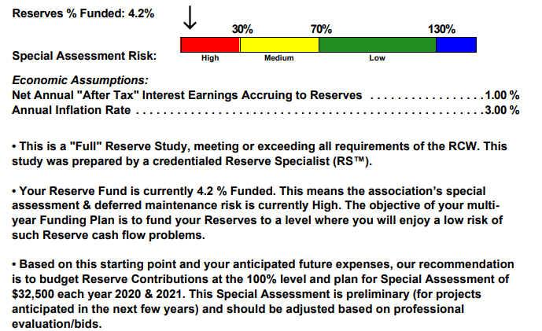

This year, we will continue to work hard to maintain the aesthetics and integrity of our community as well as protect property values for all 40 homes within RHOA. Thank you for your efforts to make Ridgemont the positive and fun community that it is!

We know that these are times of change and hardship. We will be allowing those that have hardcase situations work out a payment plan with the approval of the HOA Treasurer.

And last, but not least we really need you!!

At our Annual Meeting in March, we will hold Board elections. This is a small-time commitment and allows for your input into important decisions that pertain to the HOA and the properties within. We currently have two people doing all of the positions which isn’t a very conducive way to conduct such an important group.
So if you are interested in running, please provide a letter of intent and bio to: RidgemontHOA@outlook.com
Positions up for re-election:

- President
- Vice President
- Treasurer
- Secretary
- Member at Large

**Please note that your Board members are volunteers and do not get paid for their work on behalf of the HOA and its residents.

Sincerely,
Ridgemont HOA Board of Directors’

Jay Flores,
President & Treasurer

Terry Adamo
Vice President & Secretary

